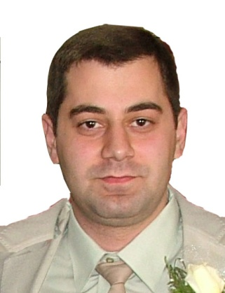
R E S U M E
Senior React Developer/Project Manager
Hayk K. Arakelyan
Yerevan, Republic of Armenia
Artashisyuan 46\16
Phone # +37410 42-21-69 (home)
Phone # +374 96 10-10-17 (mob)
E-mail: info@webex.am

Personal Data:
Date of Birth May 19, 1984

Education:
1998- 2002 High school #27, Yerevan
I have been lecturer at theGiving lessons ofPHP, MySQL, JavaScript, Flash,
“EVA”, “Suaf” educational centers
Trainings Certificates
Linux Linux administration and management
- Database management

Microsoft Website administration
- Web sites creatingby ASP.NET
- Database management (MSSQL)

Oracle University - Oracle 9i PL/SQL professional/2006 year/

High education 1. (web systems, finances in tech) and financial (billing system working tenets, accounting, finances)/5 years, master degree/
2.High Technical education in India / C-DAC - Diploma in Advanced Computing/
PG degree /Post Graduate/

Full POST Graduate EducationinHeadquarter of
C-DAC: Centre for Development of Advanced Computing/India/

Advanced knowledge by these technologies:
- React / Redux
- JavaScript / ECMAScript
- Flow / TypeScript
- CSS3 / FlexBox, SASS / LESS
- Agile software development Methodology
- Planning poker for Development by Sprint
- Oracle DB / PL/SQL
- Web Programming
- JSON, XML, XSLT, SCHEMAS, DTD, Xpath
- PHP / MySQL

Personal experience:

AppoloBytes CJSC/Germany/ - Senior React Developer
Inspections and Audit system for Port company. Management system for inspections of upcoming and entering port vessels. There was system with .Net backend and Silverlight frontend system which was working too slow, and the main aim was to make it extremely fast with strong team of freelancers we have made that system remotely.
- React/ Reduxdeveloper
- ECMAScript/ JS / Flow
- CSS3 / Flexbox
- Work by planning poker sprints
2016-2017 -7 months


- React Developer
- CSS / SASS
- ECMAScript
- PHP / MySQL

2015-2016- 14 months

Founder
of Webex Technologies LLC
2006- 2015

 Web Programming Training company

“ArmenTel” CJSC (Beeline) - E-care – Mobile services management web system, client side
2006- 2008 - Amdocs Database developer and Reporting specialist
- JavaScript, jQuery

- Digillect web builder management
- АctionPlan - Work experience with systems BIIS and MOZ

- www.beeline.am (using MS .Net)

- www.beemail.am–(using asp.net)


- E-care (Mobile Services Online Management System)
Integration
https://uslugi.beeline.am/
` 

Instigate CSJC  2005-2006 | C++, JDK, SVN… Programmer by Linux  

“Electropribor” CJSC IT manager /www.elprib.ru/
12 months 2003, 2004

“Automobile Federation of General IT Manager
Armenia” 2001-2003
24 months


“Websoft technologies”2001 HTML, CSS, JS, jQuery,
23 months

“ArmEx” Design Studio/2000/General Director, web programmer
12 months

Technical skills: Web programming: React, Redux, JS, ES6, Flow, GitTypeScript, SQL, PHP, MySQL, Oracle, MSSQL,jQuery, Flash(actionscript), XML, JSON, RSS, C, C++, Microsoft .NET, ASP.NET, Oracle, Lotus, Web builder 3.0.5, XSLetc…

Web Projects:

www.liquidworldgbr.de/Flash ActionScript 3.0 created in 2002 /

www.webex.am (PHP programing, MySQL, Flash, ActionScript)


www.armeniatv.com(CSS, JavaScript, PHP Programming, MySQL, )


Languages: -Fluent in Armenian, Russianand English


Microsoft Certificate for ASP.NET
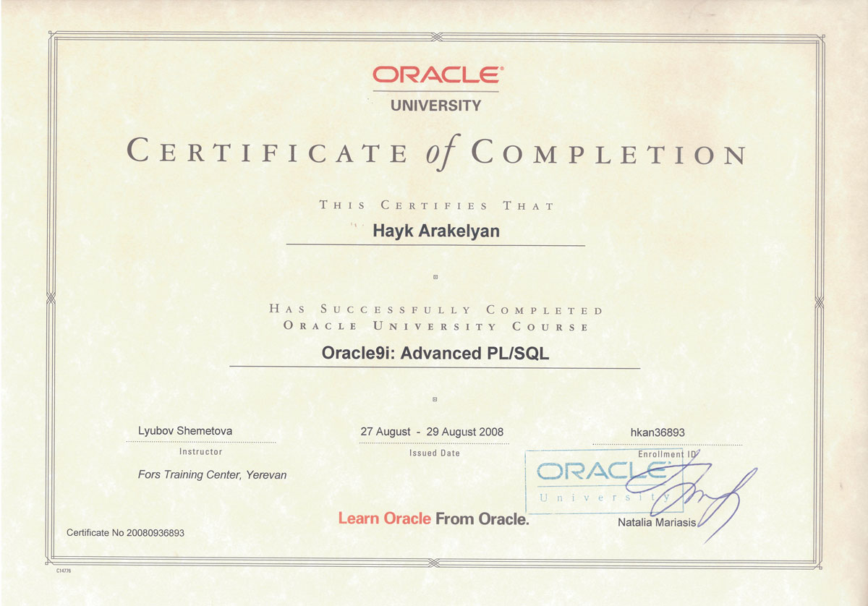
Oracle University Advanced PL/SQL knowledge
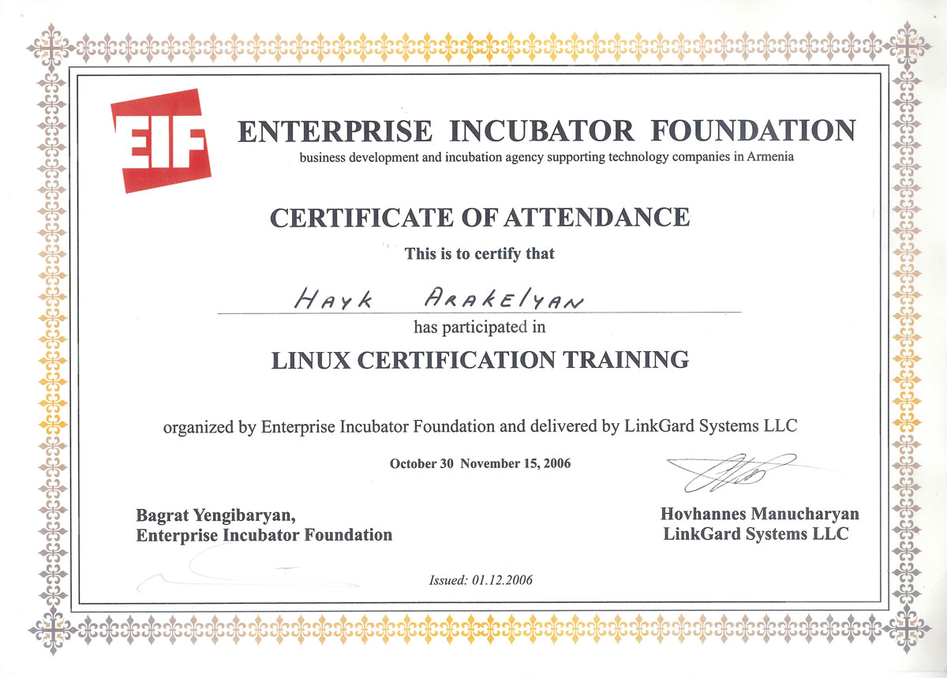
EIF certificate for Linux Knowledge

