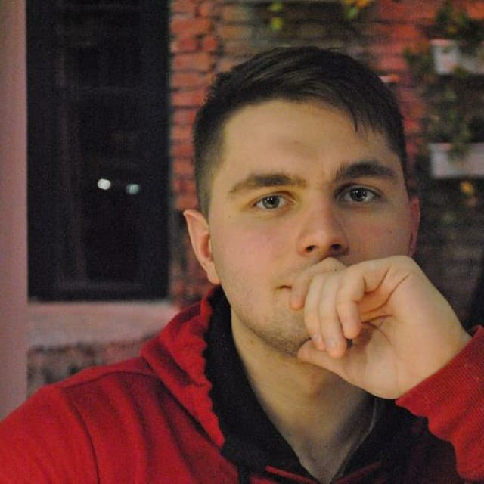
Buzoveria Dmitriy
Region: Ukraine, Kiev
Phone: 380671894795
Telegram: @ArtArtas
E-mail: shkolatlen@gmail.com
Skype: haluna245

Date of Birth: November 16, 1998

Objective:
Python Developer

Summary: Languages:
Python – 0,5 years; OOP – good knowledge; Googling excellently;
SQL - 0,5 years;
Databases:
MySQL
PostgreSQL
Tools:
PyCharm
Visual Studio Code
Framework:
Flask
VCS:
Git

Education: 2016-2020
Student
National Technical University of Ukraine
"Kyiv Polytechnic Institute named after Igor Sikorsky".
Language: English – pre-intermediate
Russian – fluent
Ukrainian - fluent

Personal information:
Native speaker of Ukrainian and Russian, a permanent resident of Kiev. Responsible, communicative, work well individually and in a team, aimed at the result. Ready to learn new technologies and do it as effectively as possible. Improve my English. Dream to become a cool developer.

